**Object Oriented Programming**

**Lab Record**

Submitted by

Shelly Miss

Submitted to

Aksa Anna Jose

Roll no:06, S2

1. Add complex numbers

public class Complex

{

double real, img;

Complex(double r, double i)

{

this.real = r;

this.img= i;

}

public static Complex sum(Complex c1, Complex c2)

{

Complex temp = new Complex(0, 0);

temp.real = c1. real+ c2.real;

temp.img = c1.img+ c2.img;

return temp;

}

public static void main(String args[])

{

Complex c1 = new Complex(2, 10);

Complex c2 = new Complex(4.5, 3.5);

Complex temp = sum(c1, c2);

System.out.printf("Sum is: "+ temp.real+" + "+ temp.img +"i");

}

}

Output

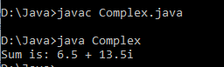

1. Define a class product with data members pcode,pname,price. Create 3 objects of the class and find the product having the lowest price.

public class product

{

int pcode;

String pname;

int price;

public static void main(String[] args)

{

int smallest;

product p1 = new product();

product p2 = new product();

product p3 = new product();

p1.pcode=2000;

p1.pname="laptop";

p1.price=10000;

p2.pcode=1110;

p2.pname="hp";

p2.price=35000;

p3.pcode=2002;

p3.pname="intel i3";

p3.price=40000;

if(p1.price<p2.price)

{

if(p3.price<p1.price)

{

smallest = p3.price;

} else {

smallest = p1.price;

}

} else {

if(p2.price<p3.price)

{

smallest = p2.price;

} else {

smallest = p3.price;

}

}

System.out.println(smallest + " is the cheapest.");

}

}

Output

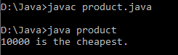

1. Read a matrix from the console and check whether it is symmetric or not.

import java.util.*;

public class mat

{

public static void main(String[] args)

{

Scanner ip=new Scanner(System.in);

System.out.println("Enter the number of row: ");

int row=ip.nextInt();

System.out.println("Enter the number of coloumn: ");

int col=ip.nextInt();

if(row==col)

{

System.out.println("Matrix is symmetric ");

}

else

System.out.println("Matrix is not symmetric ");

}

}

Output

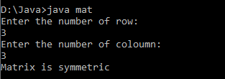

1. Create CPU with attribute price. create inner class processor (no.of cores , manufactures) and static nested class RAM (memory, manufacturer). Create an object of CPU and print information of processor and ram.

public class Cpu

{

int price;

Cpu(int p)

{

this.price = p;

}

class Processor

{

int cores;

String manufacture; Processor(int n, String m)

{

this.cores = n;

this.manufacture = m;

}

void display()

{

System.out.println("No of Cores : " + this.cores);

System.out.println("Processor manufactures : " + this.manufacture);

}

}

static class Ram

{

int memory;

String manufacture;

Ram(int n, String m)

{

this.memory = n;

this.manufacture = m;

}

void display()

{

System.out.println("Memory Size : " + this.memory);

System.out.println("Memory manufactures : " + this.manufacture);

}

}

void display()

{

System.out.println("Price of CPU : " + this.price);

}

public static void main(String[] args)

{

Cpu intel = new Cpu(30000);

Cpu.Processor i_processor = intel.new Processor(7, "intel");

Cpu.Ram i_ram = new Ram(1030, "hp");

intel.display();

i_processor.display();

i_ram.display();

}

}

Output

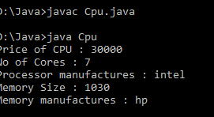

1. Area of different shapes using overload functions.

public class ShapeA2

{

int area(int side)

{

return side*side;

}

int area(int l,int b)

{

return l*b;

}

double area(double b,double h)

{

return (0.5*(b*h));

}

double area(double r)

{

return (3.14*r*r);

}

public static void main(String[] args)

{

ShapeA obj=new ShapeA();

System.out.println("Area of Square: "+obj.area(5));

System.out.println("Area of Rectangle: "+obj.area(5,4));

System.out.println("Area of Triangle:"+obj.area(5.5,2.1));

System.out.println("Area of Circle: "+obj.area(5.7));

}

}

Output

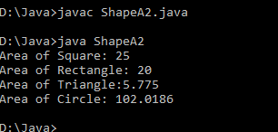

1. Create a class ‘Employee’ with data members Empid, Name, Salary, Address and constructors to initialize the data members. Create another class ‘Teacher’ that inherit the properties of class employee and contain its own data members department, Subjects taught and constructors to initialize these data members and also include display function to display all the data members. Use array of objects to display details of N teachers.

import java.util.*;

class Employee

{

int empid;

String name,address;

double salary;

public Employee(int empid, String name, String address, double salary) {

this.empid = empid;

this.name = name;

this.address = address;

this.salary = salary;

}

}

public class Teacher extends Employee

{

String subject,department;

public Teacher(int empid, String name, String address, double salary,String department,String subject ) {

super(empid, name, address, salary);

this.subject = subject;

this.department = department;

}

void display()

{

System.out.println("Empid : "+this.empid+" Name : "+this.name+" Salary : "+this.salary+" Address : "+this.address+" department : "+this.department+" Subjects : "+this.subject);

}

public static void main(String[] args) {

// TODO Auto-generated method stub

Scanner sc=new Scanner(System.in);

int n;

System.out.println("Enter number of Teachers : ");

n=sc.nextInt();

Teacher obj[]=new Teacher[n];

for(int i=0;i<n;i++) {

int j = i+1;

System.out.print("Enter Empid of teacher "+j+" : ");

int Empid = sc.nextInt();

System.out.print("Enter Name of teacher "+j+" : ");

String Name = sc.next();

System.out.print("Enter Salary of teacher "+j+" : ");

double Salary = sc.nextDouble();

System.out.print("Enter Address of teacher "+j+" : ");

String Address = sc.next();

System.out.print("Enter department of teacher "+j+" : ");

String department =sc.next();

System.out.print("Enter Subjects of teacher "+j+" : ");

String Subjects =sc.next();

obj[i] = new Teacher(Empid, Name, Address, Salary, department, Subjects);

}

System.out.println("\n-------------------------------------------------------------------------\n");

System.out.println("Teacher's List \n");

for(int i=0;i<n;i++) {

obj[i].display();

}

}

}

Output

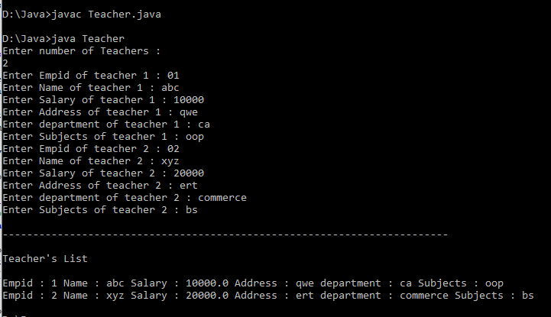

1. Create a class ‘Person’ with data members Name, Gender, Address, Age and a constructor to initialize the data members and another class ‘Employee’ that inherits the properties of class Person and also contains its own data members like Empid, Company_name, Qualification, Salary and its own constructor. Create another class ‘Teacher’ that inherits the properties of class Employee and contains its own data members like Subject, Department, Teacherid and also contain constructors and methods to display the data members. Use array of objects to display details of N teachers.

import java.util.Scanner;

class Person

{

String name,gender,address;

int age;

public Person(String name, String gender, String address, int age)

{

super();

this.name = name;

this.gender = gender;

this.address = address;

this.age = age;

}

}

class Employee extends Person

{

int empid;

String company_name,qualification;

double salary;

public Employee(String name, String gender, String address, int age, int empid, String company_name,

String qualification, double salary)

{

super(name, gender, address, age);

this.empid = empid;

this.company_name = company_name;

this.qualification = qualification;

this.salary = salary;

}

}

class Teacher extends Employee

{

String subject,department;

int teacherid;

public Teacher(String name, String gender, String address, int age, int empid, String company_name,

String qualification, double salary, String subject, String department, int teacherid)

{

super(name, gender, address, age, empid, company_name, qualification, salary);

this.subject = subject;

this.department = department;

this.teacherid = teacherid;

}

void display()

{

System.out.println("....Personal details...");

System.out.println(" Name : "+this.name+" Gender : "+this.gender+" Age :"+this.age);

System.out.println("...Employee details....");

System.out.println("Empid : "+this.empid +" company_name : "+this.company_name+" Salary : "+this.salary+" Address : "+this.address+" qualification : "+this.qualification);

System.out.println("...Teacher's details...");

System.out.println(" teacherid : "+this.teacherid+ " department : "+this.department+" Subjects : "+this.subject);

}

}

public class Main

{

public static void main(String[] args)

{

Scanner s=new Scanner(System.in);

int n;

System.out.println("Enter number of Teachers : ");

n=s.nextInt();

Teacher obj[]=new Teacher[n];

for(int i=0;i<n;i++) {

System.out.println("Enter the person name:");

String nam1=s.next();

System.out.println("Enter the Gender: ");

String gen1=s.next();

System.out.println("Enter the Address: ");

String adr1=s.next();

System.out.println("Enter the Age:");

int age1=s.nextInt();

System.out.println("Enter the Employee id: ");

int id1=s.nextInt();

System.out.println("Enter the Company name: ");

String cname1=s.next();

System.out.println("Enter the Salary:");

double sal1=s.nextDouble();

System.out.println("Enter the Qualification:");

String qu1=s.next();

System.out.println("Enter the Teacher id: ");

int tid1=s.nextInt();

System.out.println("Enter the Department:");

String dept1=s.next();

System.out.println("Enter the Subject:");

String sub1=s.next();

obj[i]=new Teacher(nam1,gen1,adr1,age1,id1,cname1,qu1,sal1,sub1,dept1,tid1);

}

System.out.println("\n-------------------------------------------------------------------------\n");

for(int i=0;i<n;i++)

{

obj[i].display();

}

}

}

Output

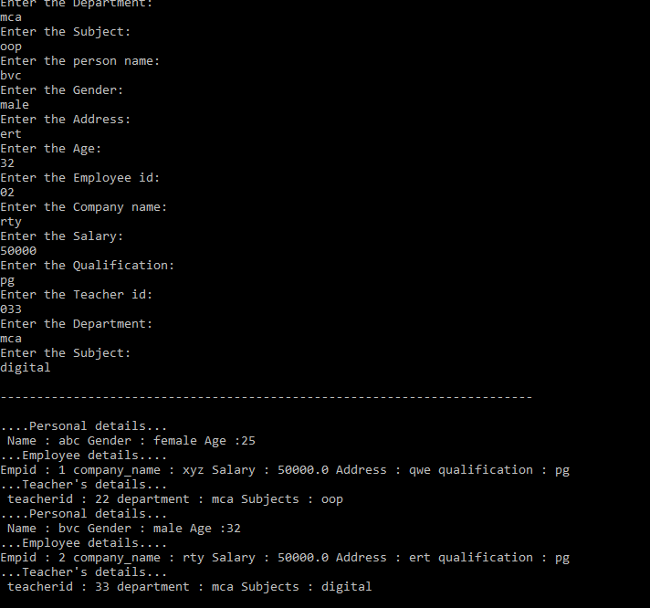

1. Write a program has class Publisher, Book, Literature and Fiction. Read the

information and print the details of books from either the category, using

inheritance.

import java.util.Scanner;

class Publisher

{

String Pubname;

Publisher()

{

Scanner s=new Scanner(System.in);

System.out.println("Enter publisher name");

Pubname=s.next();

}

}

class Book extends Publisher

{

String title, author;

int price;

Book()

{

Scanner s=new Scanner(System.in);

System.out.println("Enter Title of the book");

title=s.next();

System.out.println("Enter Author's name");

author=s.next();

System.out.println("Enter price");

price=s.nextInt();

}

}

class Literature extends Book

{

Literature()

{

System.out.println("Literature Books");

}

void display()

{

System.out.println("Publisher name: "+Pubname);

System.out.println("Title of the book: "+title);

System.out.println("Author's name: "+author);

System.out.println("Price: "+price);

}

}

class Fiction extends Literature

{

Fiction()

{

System.out.println("Friction Books");

}

void display()

{

super.display();

}

public static void main(String args[])

{

int n;

Scanner s=new Scanner(System.in);

System.out.println("Enter the No of literature book: ");

int a=s.nextInt();

Literature L[]=new Literature[a];

for(int i=0;i<a;i++)

{

L[i]=new Literature();

}

System.out.println("Enter the No of Fiction book: ");

int b=s.nextInt();

Fiction F[]=new Fiction[b];

for(int i=0;i<b;i++)

{

F[i]=new Fiction();

}

int no;

System.out.println("Enter your choice of book");

no=s.nextInt();

int type =no;

switch (no)

{

case 1:

System.out.println(".....Details of literature books");

for(int i=0;i<a;i++)

L[i].display();

break;

case 2:

System.out.println(".....Details of fiction books");

for(int i=0;i<b;i++)

F[i].display();

break;

default:

System.out.println("Wrong input");

}

}

}

Output

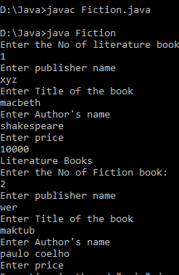

1. Create classes Student and sports.Create another class result inherited from student and sports.Display the academic and sports score of a student.

interface student

{

void stresullt();

}

interface sports

{

void spresult();

}

class result implements student,sports

{

public void spresult()

{

String eighthundred="First";

String twohundred="Second";

String longjump="First";

String relay="Second";

System.out.println("Sports Result");

System.out.println("eight hundered merter:"+ eighthundred);

System.out.println("Two Hundred Meter:"+twohundred);

System.out.println("long jump:"+longjump);

System.out.println("Relay:"+relay);

}

public void stresullt()

{

int physics=50;

int chemistry=60;

int biology=40;

int hindi=40;

int social=78;

System.out.println("Marks");

System.out.println("physics:"+physics);

System.out.println("chemistry:"+chemistry);

System.out.println("biology:"+biology);

System.out.println("hindi:"+hindi);

System.out.println("social:"+social);

}

public static void main(String[] args)

{

result r = new result(); r.stresullt();

r.spresult();

}

}

Output

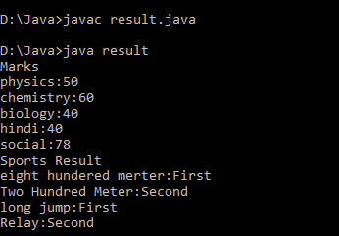

1. Create an interface having prototype of functions area() and perimeter().Create two classes circle and rectangle which implements the above interface. Create a menu driven program to find area and perimeter of objects.

import java.util.Scanner;

interface Shape

{

void input();

void area();

void perimeter();

}

class Circle implements Shape

{

int r = 0;

double pi = 3.14, ar = 0,per=0;

public void input()

{ Scanner s = new Scanner(System.in); System.out.print("Enter radius of circle:");

r= s.nextInt();

}

public void area()

{

ar = pi * r * r;

System.out.println("Area of circle:"+ar);

}

public void perimeter()

{

per = 2 * pi * r;

System.out.println("Perimeter of circle:"+per);

}

}

class Rectangle implements Shape

{

int l = 0, b = 0;

double ar,per;

public void input()

{ Scanner s = new Scanner(System.in);

System.out.print("Enter length of rectangle:");

l = s.nextInt();

System.out.print("Enter breadth of rectangle:");

b = s.nextInt();

}

public void area()

{

ar = l * b;

System.out.println("Area o}

public void perimeter()

{

per = 2 * (l + b);

System.out.println("Perimeter of rectangle:"+per);

}

}public class Shapes

{

public static void main(String[] args)

{ int n;

Scanner s = new Scanner(System.in);

Rectangle obj1 = new Rectangle();

Circle obj2 = new Circle(); System.out.println("1.Area of circle");

System.out.println("2.Perimeter of circle");

System.out.println("3.Area of rectangle");

System.out.println("4.Perimeter of rectangle");

System.out.println("Enter your option:");

n= s.nextInt();

switch(n) {

case 1:

obj2.input();

obj2.area();

break;

case 2:

obj2.input();

obj2.perimeter();obj2.input();

obj2.area();

break;

case 4:

obj2.input();

obj2.perimeter();

break;

default:

System.out.println("Invalid option");

break;

case 3:

obj2.input();

obj2.area();

break;

case 4:

obj2.input();

obj2.perimeter();

break;

default:

System.out.println("Invalid option");

}

}

}

Output

1. Prepare bill with the given format using calculate method from interface. Order No.Date Productid name quantity price total 101 A 2 25 50 102 B 1 100 100 Net.Amount 150

interface bill

{

int productdetails();

}

class product1 implements bill

{

int id = 101,quantity= 2,unit=25,total=0; String name="A";

public int productdetails()

{

total = quantity * unit;

System.out.println("Product Id :"+id);

System.out.println("Name :"+name);

System.out.println("Quantity :"+quantity);

System.out.println("Unit price :"+unit);

System.out.println("Total :"+total);

return(total);

}

}

class product2 implements bill{

int id = 102,quantity= 1,unit=100,total=0;

String name="B";

public int productdetails()

{

total = quantity * unit;

System.out.println("Product Id :"+id);

System.out.println("Name :"+name);

System.out.println("Quantity :"+quantity);

System.out.println("Unit price :"+unit);

System.out.println("Total :"+total);

return(total);

}

}

public class productbill

{

public static void main(String[] args)

{

product1 p1 = new product1();

product2 p2 = new product2();

int t1= p1.productdetails();

int t2= p2.productdetails();

int t3=t1+t2;

System.out.println("Net. Amount :"+t3);

}

}

Output

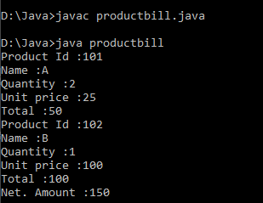

1. Program to sort string

public class sortstring

{

public static void main(String[] args)

{

String names[]={"amal","jyothi","college","of","engineering"};

String temp;

int n= names.length;

int i;

int j;

for(i=0;i<n;i++)

{

for(j=i+1;j<n;j++)

{

if(names[i].compareTo(names[j])>0)

{

temp=names[i];

names[i]=names[j];

names[j]=temp;

}

}

}

System.out.println("the sorted array of string is :");

for(i=0;i<n;i++)

{

System.out.println(names[i]);

}

}

}

Output

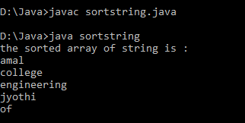

1. Search an element in an array

import java.util.*;

public class searchele

{

public static void main(String[] args)

{

int n,i,b,flag=0;

Scanner s=new Scanner(System.in);

System.out.println("enter the number of elements for the array :");

n=s.nextInt();

int a[]=new int[n];

System.out.println("enter the elements of the array :");

for(i=0;i<n;i++)

{

a[i]=s.nextInt();

}

System.out.println("enter the element u want to search :");

b=s.nextInt();

for(i=0;i<n;i++)

{

if(a[i]==b)

{

flag=1;

break;

}

else

{

flag=0;

}

}

if(flag==1)

{

System.out.println("element found at position :"+(i+1));

}

else

{

System.out.println("element not found");

}

}

}

Output

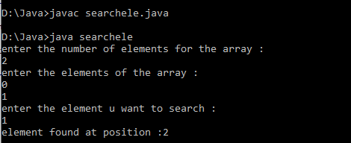

1. Perform string manipulation

public class Sample_String

{

public static void main(String[] args)

{

String str_Sample = "RockStar";

System.out.println("Length of String: " + str_Sample.length());

System.out.println("Character at position 5: " + str_Sample.charAt(5));

System.out.println("EndsWith character 'r': " + str_Sample.endsWith("r"));

System.out.println("Replace 'Rock' with 'Duke': " + str_Sample.replace("Rock", "Duke"));

}

}

Output

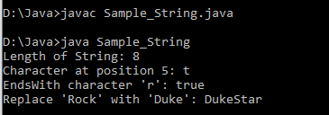

1. Java program to create generic stack and do the push and pop operation

A stack class is provided by the Java collection framework and it implements the Stack data structure. The stack implements LIFO i.e. Last In First Out. This means that the elements pushed last are the ones that are popped first.

1. push() Method adds element x to the stack.

2. pop() Method removes the last element of the stack.

3. top() Method returns the last element of the stack.

4. empty() Method returns whether the stack is empty or not.

import java.io.*;

import java.util.*;

public class Examplee

{

public static void main (String[] args)

{

Stack<Integer> s = new Stack<Integer>();

s.push(5);

s.push(1);

s.push(9);

s.push(4);

s.push(8);

System.out.print("The stack is: " + s);

System.out.print("\nThe element popped is: ");

Integer num1 = (Integer) s.pop();

System.out.print(num1);

System.out.print("\nThe stack after pop is: " + s);

Integer pos = (Integer) s.search(9);

if(pos == -1)

System.out.print("\nThe element 9 not found in stack");

else

System.out.print("\nThe element 9 is found at position " + pos + " in stack");

}

}

Output

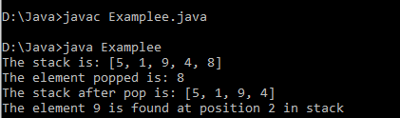

Generic method implement bubble sort Bubble sort is a simple sorting algorithm. This sorting algorithm is a comparison-based algorithm in which each pair of adjacent elements is compared and the elements are swapped

if they are not in order. This algorithm is not suitable for large datasets as its average and worst case complexity is of Ο(n2) where n is the number of items.

public class BubbleSort

{

static void bubbleSort(int[] arr)

{

int n = arr.length;

int temp = 0;

for(int i = 0; i < n; i++) {

for(int j=1; j < (n-i); j++) {

if(arr[j-1] > arr[j]) {

temp = arr[j-1];

arr[j-1] = arr[j];

arr[j] = temp;

}

}

}

}

public static void main(String[] args) {

int arr[] = { 2, 5, -2, 6, -3, 8, 0, -7, -9, 4 };

System.out.println("Array Before Bubble Sort");

for(int i = 0; i < arr.length; i++) {

System.out.print(arr[i] + " ");

}

System.out.println();

bubbleSort(arr);

System.out.println("Array After Bubble Sort");

for(int i = 0; i < arr.length; i++)

{

System.out.print(arr[i] + " ");

}

}

}

Output

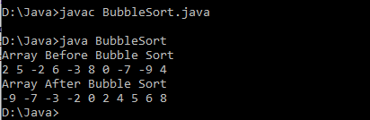

1. Maintain a list of string using arraylist from a collection of framework, perform builtin operation The ArrayList class extends AbstractList and implements the List interface. ArrayList supports dynamic arrays that can grow as needed. Standard Java arrays are of a fixed length. After arrays are created, they cannot grow or shrink, which means that you must know in advance how many elements an array will hold. Array lists are created with an initial size. When this size is exceeded, the collection is automatically enlarged. When objects are removed, the array may be shrunk.

import java.util.*;

public class ArrayListDemo

{

public static void main(String args[])

{

// create an array list

ArrayList al = new ArrayList();

System.out.println("Initial size of al: " + al.size());

// add elements to the array list

al.add("C");

al.add("A");

al.add("E");

al.add("B");

al.add("D");

al.add("F");

al.add(1, "A2");

System.out.println("Size of al after additions: " + al.size());

// display the array list

System.out.println("Contents of al: " + al);

// Remove elements from the array list

al.remove("F");

al.remove(2);

System.out.println("Size of al after deletions: " + al.size());

System.out.println("Contents of al: " + al);

}

}

Output

Initial size of al:0

Size of al after addition:7

Contents of al:[C, A2, A,E, B,D,F]

Size of al after deletion:5

Contents of al:[C,A2,E,B,D]

1. Write a user defined exception class to authentication the username and password.

import java.util.Scanner;

class UsernameException extends Exception

{

public UsernameException(String msg)

{

super(msg);

}

}

class PasswordException extends Exception

{

public PasswordException(String msg)

{

super(msg);

}

}

public class checkLogin

{

public static void main(String[] args)

{

Scanner s = new Scanner(System.in);

String username, password;

System.out.print("Enter username :: ");

username = s.nextLine();

System.out.print("Enter password :: ");

password = s.nextLine();

int length = username.length();

try

{

if(length < 6)

throw new UsernameException("Username must be greater than 6 characters ???");

else if(!password.equals("hello"))

throw new PasswordException("Incorrect password\nType correct password ???");

else

System.out.println("Login Successful !!!");

}

catch (UsernameException u)

{

u.printStackTrace();

}

catch (PasswordException p)

{

p.printStackTrace();

}

finally {

System.out.println("The finally statement is executed");

}

}

}

Output

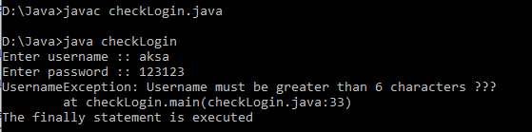

1. Find the average of N positive integers raising a user defined exception for each negative input

import java.util.Scanner;

import java.util.InputMismatchException;

public class TestDemo

{

public static void main(String args[])

{

double total = 0, N, userInput;

Scanner input = new Scanner(System.in);

while (true)

{

System.out.print("Enter how many numbers(N) to calculate average:");

userInput = input.nextDouble();

if (userInput > 0)

{

N = userInput;

break;

}

else

System.out.println("N must be positive.");

}

for (int i = 0; i < N; i++)

{

while (true)

{

System.out.print("Enter number:");

try

{

userInput = input.nextDouble();

total += userInput;

break;

}

catch (InputMismatchException e)

{

input.nextLine();

System.out.println("Input must bea number. Try again");

}

}

}

System.out.println("Average: "+ total / N);

}

}

Output

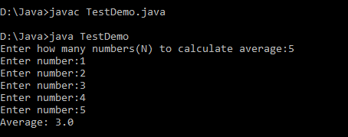

19) Define 2 classes one for generating multiplication table of 5 and other for displaying first N prime numbers implement using threads(thread class)

class ThreadA extends Thread

{

public void run()

{

int n = 5;

for (int i = 1; i <= 10; ++i)

System.out.println(n + " * " + i +

" = " + n * i);

System.out.println("Exiting from Thread A ...");

}

}

class ThreadB extends Thread

{

public void run( )

{

Scanner sc = new Scanner(System.in);

int i,n,p,count,flag;

System.out.println("Enter the number of prime terms you want!");

n=sc.nextInt();

System.out.println("First "+n+" prime numbers are :-");

p=2;

i=1;

while(i<=n)

{

flag=1;

for(count=2;count<=p-1;count++)

{

if(p%count==0) //Will be true if p is not prime

{

flag=0;

break; //Loop will terminate if p is not prime

}

}

if(flag==1)

{

System.out.print(p+" ") ;

i++;

}

p++;

}

}

System.out.println("Exiting from Thread B ...");

}

}

public class Demonstration_111

{

public static void main(String args[])

{

ThreadA a = new ThreadA();

ThreadB b = new ThreadB();

a.start();

b.start();

System.out.println("... Multithreading is over ");

}

}

20)

Define 2 classes one for generating fibanocci numbers and other for displaying even numers in a given range.implement using threads(runnable interface)

public class Mythread

{

public static void main(String[] args)

{

Runnable r = new Runnable1();

Thread t = new Thread(r);

t.start();

Runnable r2 = new Runnable2();

Thread t2 = new Thread(r2);

t2.start();

}

}

class Runnable2 implements Runnable

{

public void run(){

for(int i=0;i<11;i++){

if(i%2 == 1)

System.out.println(i);

}

}

}

class Runnable1 implements Runnable

{

public void run(){

int n1=0,n2=1,n3,i,count=10;

System.out.print(n1+" "+n2);//printing 0 and 1

for(i=2;i<count;++i)//loop starts from 2 because 0 and 1 are already printed

{

n3=n1+n2;

System.out.print(" "+n3);

n1=n2;

n2=n3;

}

}

}

Output

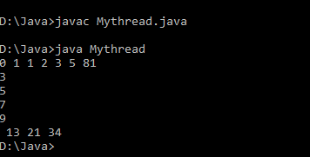

21)

Program to draw circle,rectangle,line in applet

import java.awt.*;

import java.applet.*;

public class line extends Applet

{

public void paint(Graphics g)

{

g.drawLine(100,10,250, 150);

g.drawLine(100,150,150,10);

g.setColor(Color.black);

g.drawRect(300, 50, 100, 100);

g.setColor(Color.black);

g.drawOval(500,30,100,100);

}

}

<html>

<head>

</head>

<body>

<applet code = "line.class" width = "420" height = "320"></applet>

</body>

</html>

Output

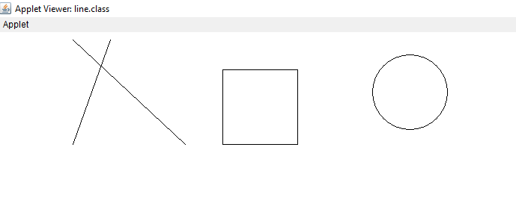

22)

Program to find maximum of three numbers using AWT

import java.awt.*;

import java.awt.Event;

import java.applet.*;

public class largest extends Applet

{

TextField Txt1,Txt2,Txt3;

public void init(){

Txt1 = new TextField(10);

Txt2 = new TextField(10);

Txt3 = new TextField(10);

add(Txt1);

add(Txt2);

add(Txt3);

}

public void paint(Graphics g)

{

int a, b, c,result;

String str;

g.drawString("Enter the numbers ",15,15);

str=Txt1.getText();

a=Integer.parseInt(str);

str=Txt2.getText();

b=Integer.parseInt(str);

str=Txt3.getText();

c=Integer.parseInt(str);

if (a>=b && a>=c)

{

result=a;

}

else if(b>=a && b>=c)

{

result=b;

}

else

{

result=c;

}

g.drawString("Largest number is "+result,10,70);

}

public boolean action(Event e, Object o){

repaint();

return true;

}

}

<html>

<head>

</head>

<body>

<div align="center">

<applet code="largest.class"width="800"height="500">

</applet>

</div>

</body>

</html>

Output

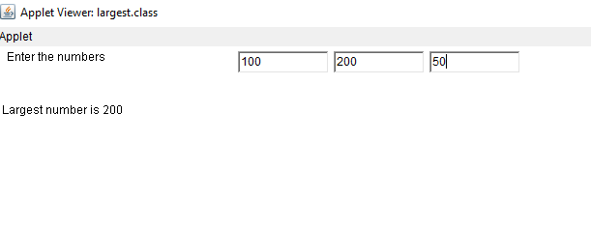

23) Find the percentage of marks obtained by a student in 5 subject. Display a

Happy face if he secures above 50% or sad face if otherwise.

import java.awt.*;

import java.awt.event.*;

import java.applet.*;

public class marks extends Applet implements ActionListener

{

public int per =0;

Label l1 = new Label("enter Marks of Subject 1: ");

Label l2 = new Label("enter Marks of Subject 2: ");

Label l3 = new Label("enter Marks of Subject 3: ");

Label l4 = new Label("enter Marks of Subject 4: ");

Label l5 = new Label("enter Marks of Subject 5: ");

Label l6 = new Label("Total Percentage: ");

TextField t1 = new TextField(10);

TextField t2 = new TextField(10);

TextField t3 = new TextField(10);

TextField t4 = new TextField(10);

TextField t5 = new TextField(10);

TextField t6 = new TextField(10);

Button b1 = new Button("CALCULATE PERCENTAGE");

public marks()

{

l1.setBounds(50, 100, 280, 20);

l2.setBounds(50, 150, 280, 20);

l3.setBounds(50, 200, 280, 20);

l4.setBounds(50, 250, 280, 20);

l5.setBounds(50, 300, 280, 20);

l6.setBounds(50, 350, 280, 20);

t1.setBounds(200, 100, 300, 20);

t2.setBounds(200, 150, 300, 20);

t3.setBounds(200, 200, 300, 20);

t4.setBounds(200, 250, 300, 20);

t5.setBounds(200, 300, 300, 20);

t6.setBounds(200, 350, 300, 20);

b1.setBounds(200,400, 200, 20);

GridLayout g1 = new GridLayout(20, 2, 5, 5);

setLayout(g1);

add(l1);

add(t1);

add(l2);

add(t2);

add(l3);

add(t3);

add(l4);

add(t4);

add(l5);

add(t5);

add(l6);

add(t6);

add(b1);

b1.addActionListener(this);

}

@Override

public void actionPerformed(ActionEvent e)

{

// TODO Auto-generated method stub

int m1 = Integer.parseInt(t1.getText());

int m2= Integer.parseInt(t2.getText());

int m3= Integer.parseInt(t3.getText());

int m4= Integer.parseInt(t4.getText());

int m5= Integer.parseInt(t5.getText());

if(e.getSource()==b1)

{

int add=m1+m2+m3+m4+m5;

per=add/5;

t6.setText(String.valueOf(per)+" %");

repaint();

}

}

public void paint(Graphics g)

{

if(per>=50)

{

g.setColor(Color.yellow);

g.drawOval(80, 700, 150, 150);

g.fillOval(80, 700, 150, 150);

g.fillOval(120, 740, 15, 15);

g.fillOval(170, 740, 15, 15);

g.drawArc(130, 800, 50, 20, 180, 180);

int x[] = {95,85,106,95};

int y[] = {85,104,104,85};

}

else if(per>0 && per<50)

{

g.setColor(Color.yellow);

g.drawOval(80, 700, 150, 150);

g.fillOval(80, 700, 150, 150);

g.fillOval(120, 740, 15, 15);

g.fillOval(170, 740, 15, 15);

g.drawArc(130,820,50,20,0,180);

int x[] = {95,85,106,95};

int y[] = {85,104,104,85};

}

}

public static void main(String args[])

{

new marks();

}

}

<html>

<head>

</head>

<body>

<div align="center">

<applet code="marks.class"width="800"height="500">

</applet>

</div>

</body>

</html>

Output

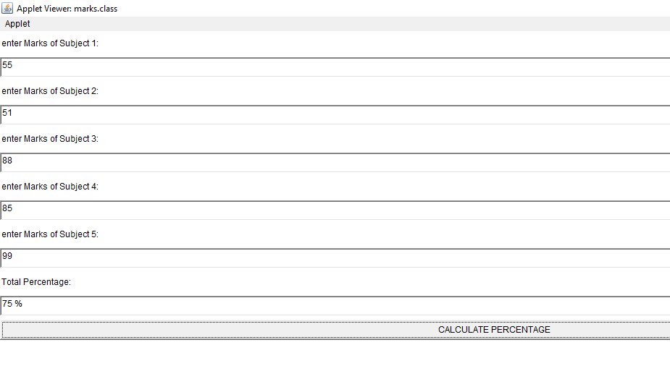

24) Using 2D graphics commands in an applet, construct a house. On mouse click event change the color of the door from blue to red

import java.awt.*;

import java.applet.*;

import java.awt.event.*;

public class house extends Applet implements MouseListener, Runnable

{

private Color doorColor = Color.WHITE;

public void paint(Graphics gp)

{

int[] i = { 150, 300, 225 };

int[] j = { 150, 150, 25 };

gp.drawRect(150, 150, 150, 200);

gp.drawOval(200, 75, 50, 50);

gp.drawPolygon(i, j, 3);

gp.setColor(doorColor);

gp.fillRect(200, 200, 50, 150);

gp.setColor(Color.BLACK);

gp.drawRect(200, 200, 50, 150);

}

public void init()

{

this.setSize(200, 200);

addMouseListener(this);

}

public void run()

{

while (true)

{

repaint();

try {

Thread.sleep(17);

} catch (InterruptedException e)

{

e.printStackTrace();

}

}

}

public void mouseClicked(MouseEvent e)

{

int x = e.getX(), y = e.getY();

if (x >= 200 && x <= 250 && y >= 200 && y <= 350)

doorColor = Color.RED;

else

doorColor = Color.BLUE;

repaint();

System.out.println("Mouse Position : X=" + x + " Y=" + y + "");

}

public void mousePressed(MouseEvent e)

{

}

public void mouseReleased(MouseEvent e)

{

}

public void mouseEntered(MouseEvent e)

{

}

public void mouseExited(MouseEvent e)

{

}

}

<html>

<head>

</head>

<body>

<div align="center">

<applet code="house.class" width="800" height="500">

</applet>

</div>

</body>

</html>

Output

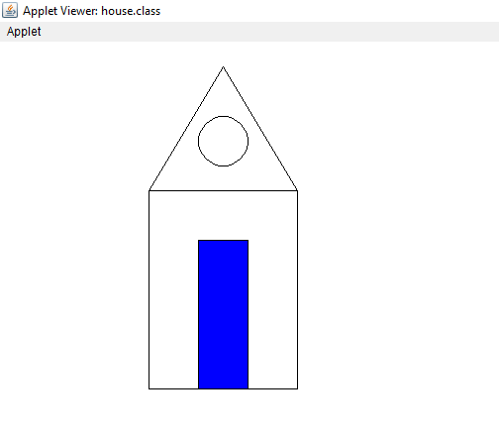

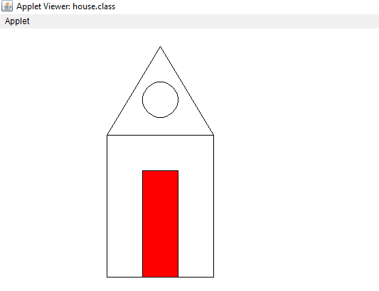

25) Implement a simple calculator using AWT components

import java.awt.*;

import java.awt.event.*;

import java.applet.*;

public class calc extends Applet implements ActionListener

{

Frame f = new Frame();

Label l1 = new Label("enter number");

Label l2 = new Label("enter number");

Label l3 = new Label("result");

TextField t1 = new TextField(10);

TextField t2 = new TextField(10);

TextField t3 = new TextField(10);

Button b1 = new Button("ADD");

Button b2 = new Button("SUB");

Button b3 = new Button("MUL");

Button b4 = new Button("DIV");

calc() {

l1.setBounds(50, 100, 100, 20);

l2.setBounds(50, 100, 100, 20);

l3.setBounds(50, 100, 100, 20);

t1.setBounds(200, 100, 100, 20);

t2.setBounds(250, 150, 100, 20);

t3.setBounds(300, 200, 100, 20);

b1.setBounds(50, 250, 50, 20);

b2.setBounds(110, 250, 50, 20);

b3.setBounds(170, 250, 50, 20);

b4.setBounds(230, 250, 50, 20);

f.add(l1);

f.add(t1);

f.add(l2);

f.add(t2);

f.add(l3);

f.add(t3);

f.add(b1);

f.add(b2);

f.add(b3);

f.add(b4);

b1.addActionListener(this);

b2.addActionListener(this);

b3.addActionListener(this);

b4.addActionListener(this);

f.setLayout(null);

f.setVisible(true);

f.setSize(500, 500);

}

public void actionPerformed(ActionEvent e)

{

int i = Integer.parseInt(t1.getText());

int j = Integer.parseInt(t2.getText());

if (e.getSource() == b1)

{

t3.setText(String.valueOf(i + j));

}

if (e.getSource() == b2)

{

t3.setText(String.valueOf(i - j));

}

if (e.getSource() == b3)

{

t3.setText(String.valueOf(i * j));

}

if (e.getSource() == b4)

{

t3.setText(String.valueOf(i / j));

}

}

public static void main(String args[])

{

new calc();

}

}

<html>

<head>

</head>

<body>

<div align="center">

<applet code="calc.class"width="800"height="500">

</applet>

</div>

</body>

</html>

Output

26)

Develop a program that has a choice component which contains the names of shapes such as rectangle ,triangle.square and circle,Draw the corresponding shapes for given parameters as per user’s choice.

import java.applet.Applet;

import java.awt.*;

import java.awt.Graphics;

import java.awt.event.*;

public class figchoice extends Applet implements ItemListener

{

Choice ch;

int x1[]= {50,120,220,20};

int y1[]= {50,120,20,20};

int n=4;

int Selection;

public void init()

{

ch = new Choice();

ch.addItem("Select a Shape");

ch.addItem("Rectangle");

ch.addItem("Triangle");

ch.addItem("Square");

ch.addItem("Circle");

add(ch);

ch.addItemListener(this);

}

public void itemStateChanged (ItemEvent e)

{

Selection = ch.getSelectedIndex();

repaint();

}

public void paint(Graphics g)

{

super.paint(g);

if (Selection == 1)

{

g.drawRect(50,50,100,150);

}

if (Selection == 2)

{

g.drawPolygon(x1,y1,n);

}

if (Selection == 3)

{

g.drawRect(50,50,100,100);

}

if (Selection == 4)

{

g.drawOval(70,30,100,100);

}

<html>

<head>

</head>

<body>

<div align="center">

<applet code="figchoice.class"width="800"height="500">

</applet>

</div>

</body>

</html>

Output

27) Maintain a list of Strings using ArrayList from collection framework, perform built-inimport java.util.*;

import java.util.*;

public class arrayjava

{

public static void main(String args[])

{

arrayList<String> list=new arrayList<String>();

list.add("appu");

list.add("ammu");

list.add("minnu");

list.add("thomu");

list.add("pinky");

list.add("Tom");

//displaying elements

System.out.println(list);

//Adding "appu" at the fourth position

list.add(3, "appu");

//displaying elements

System.out.println(list);

}

}

Output

28) **Program to remove all the elements from a linked list**

import java.util.*;

public class removelink {

public static void main(String[] args) {

// create an empty linked list

LinkedList<String> l_list = new LinkedList<String>();

// use add() method to add values in the linked list

l_list.add("violet");

l_list.add("Green");

l_list.add("Black");

l_list.add("Pink");

l_list.add("blue");

// print the list

System.out.println("The Original linked list: " + l_list);

// Removing all the elements from the linked list

l_list.clear();

System.out.println("The New linked list: " + l_list);

}

}

Output

29) program to demonstrate the addition and deletion of elements in dequeue

import java.util.*;

public class DequeExample {

public static void main(String[] args)

{

Deque<String> deque

= new LinkedList<String>();

deque.add("Element 1 (Tail)");deque.addFirst("Element 2 (Head)");

deque.addLast("Element 3 (Tail)");

deque.push("Element 4 (Head)");

deque.offer("Element 5 (Tail)");

deque.offerFirst("Element 6 (Head)")

System.out.println(deque + "\n");

deque.removeFirst();

deque.removeLast();

System.out.println("Deque after removing "

+ "first and last: "

+ deque);

}

}

Output

30)

program to demonstrate the working of map interface byadding,removing,changing

import java.util.*;

class hashmap

{

public static void main(String args[])

{

Map<String, Integer> hm

= new HashMap<String, Integer>();

hm.put("a", new Integer(200));

hm.put("b", new Integer(400));

hm.put("c", new Integer(600));

hm.put("d", new Integer(800));

// Traversing through the map

for (Map.Entry<String, Integer> me : hm.entrySet())

{

System.out.print(me.getKey() + ":");

System.out.println(me.getValue());

}

}

}

Output

31) program to convert hash map to tree map

import java.util.*;

import java.util.stream.*;

public class HT {

public static void main(String args[])

{

Map<String, String> map = new HashMap<>();

map.put("1", "One");

map.put("2", "Two");

map.put("3", "Three");

map.put("4", "Four");

map.put("5", "Five");

map.put("6", "Six");

map.put("7", "Seven");

map.put("8", "Eight");

map.put("9", "Nine");

System.out.println("HashMap = " + map);

Map<String, String> treeMap = new TreeMap<>();

treeMap.putAll(map);

System.out.println("TreeMap (HashMap to TreeMap) " + treeMap);

}

} output